Steps | Detergent | Dilute | Diluted Coverage | TASKI Pads & Brushes
Initial Cleaning | Buckeye Blue  TASKI profi™ | 2 oz / gal water  10 oz / gal water | 180 to 360 sq ft / gal | Soft nylon brush
Neutral Cleaner | Buckeye Blue  TASKI profi™ | 4 oz / gal water  10 oz / gal water | 180 to 360 sq ft / gal | Contact pad, purple pad or soft nylon brush
Heavy Soil Cleaner | Buckeye Blue  TASKI profi™ | 8 oz / gal water  10 oz / gal water | 180 to 360 sq ft / gal | Contact pad, purple pad or soft nylon brush
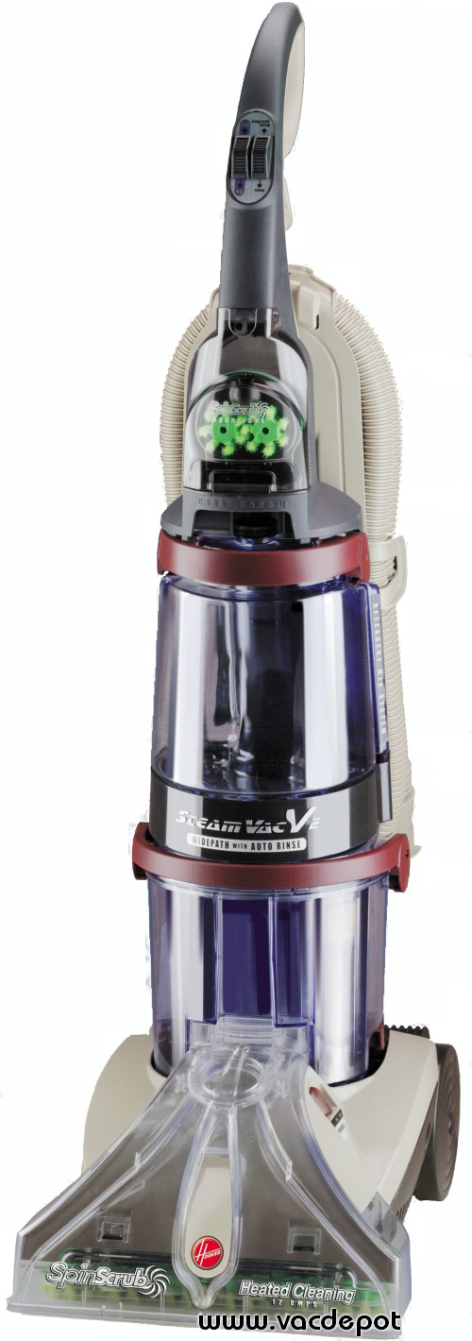
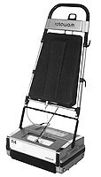

Broom Wet Mop Wet/Dry Vacuum Auto Scrubber Buffer SteamVac Rotowash
I. Cleaning Instructions

Initial Cleaning
- Remove all surface soil, debris, sand and grit with a vacuum.
- Scrub floor with a neutral detergent.
- Pick up solution with a wet vacuum, rinse with clean water and allow to dry thoroughly.
- This process may be done in one or two steps with a Rotowash or SteamVac.

Daily / Regular Cleaning
- Sweep or vacuum floor to remove surface soil, debris, sand and grit.
- Damp mop the floor.
- This process may be done in one or two steps with a Rotowash or SteamVac.
- Allow floor to dry thoroughly.

Interim Maintenance
- Vacuum floor thoroughly.
- Aggressively scrub the floor with a neutral detergent. Use the rotary scrubber or Rotowash.
- Vacuum any remaining soiled solution with a wet/dry vacuum.
- Allow floor to dry thoroughly.

Restorative Maintenance
- Vacuum floor thoroughly.
- Scrub using a rotary scrubber or a Rotowash and neutral cleaner.
- Pick up solution with wet vacuum or SteamVac.
- Allow floor to dry thoroughly.

Page 1 of 2

II. Equipment Specifications
SteamVac Machine | Similar to any Hoover SteamVac model with scrubber and vacuum.
Rotowash Machine | Model R-4 with a 15 inch cleaning width for large areas. The smaller R-3 model with an 11 inch cleaning width works well around equipment. Roto Wash is available from the manufacturer at www.rewhittaker.com/qstore.
Power Scrubber | 17 inch rotary floor buffer with mounted detergent tank and feed line to the brush. A circular brush attachment should be used.
Wet/Dry Shop Vacuum Unit | Power Unit: Minimum 1.7 hp commercial unit, 7.0 amp, 120vlt A.C., 50/60 Hz two stage bypass motor  Tank Capacity: 10-25 gallon, lined stainless stel or polypropylene.  Accessories: Extension wand with a 6 to 12 inch pickup nozzle, crevice tool, heavy-duty extension cord.
Detergent | Commercial/Industrial non-petroleum based neutral detergent.  - Buckeye Blue  - TASKI profi™, TASKI ice it™ or their equivalent.

Important Maintenance tips

- Use high CFM vacuum to pick up dust.
- For large areas, use the Rotowash Model R-4B.
- Dilute the detergents with water per the manufacturers instructions; use higher concentrations for stubborn stains or hard to clean areas.
- Rinse, wet vacuum or mop up any detergent residue when cleaning the floor.
- For gum, use generic gum remover, however, any solvent-based product should be rinsed well with water to avoid damaging floor.
- DO NOT use an Auto Scrubber with a squeegee attachment. It tends to not pick up all of the dirty water solution and leaves a film of diluted dirty water on the tiles.
- DO NOT use petroleum or citrus based detergents.

Contact Buckeye Blue Customer Care at 800-321-2583 for a distributor in your area.
Contact TASKI Customer Care at 800-862-3400 for a distributor in your area.

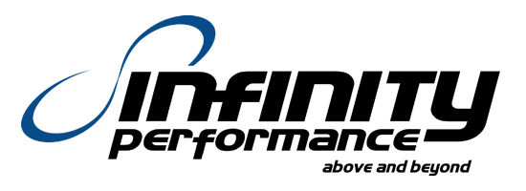

Page 2 of 2 888-479-101

